Defects Liability Request Form

Recipient | Sender
Company: VDL Weweler  Ecofactorij 10  NL-7325 WC Apeldoorn | Company:
Department: Aftersales | Department:
 | Name:
E-mail: aftersales@vdlweweler.nl  Phone No.: +31 (0) 55 5385132 | E-mail:  Phone No.:
 | Date:

Your claim can only be processed by VDL when this form is filled out completely and photos of the damaged part(s) are included.
Please check “VDL Weweler Truck & Bus Manual general” (available on www.vdlweweler.nl) for more detailed information about the specific parts of the system.

If VDL informs you that no further examination is required and the part may be scrapped, please do so as environmentally friendly as possible.

Required information

Customer defects liability
request No.
Detailed explanation of the problem

Circumstances that caused the malfunction

Vehicle and/ or product information | Type of vehicle
Vehicle and/ or product information | Vehicle specification
Vehicle and/ or product information | System specification
Vehicle and/ or product information | Location/ Address
Vehicle and/ or product information | Contact Information
Vehicle and/ or product information | Contact
Vehicle and/ or product information | Chassis Number / VIN No.
Vehicle and/ or product information | Mileage (Km)
Vehicle and/ or product information | Country of registration
Vehicle and/ or product information | Registration Date (d-m-y)
Vehicle and/ or product information | Vehicle Owner

Position under the vehicle:
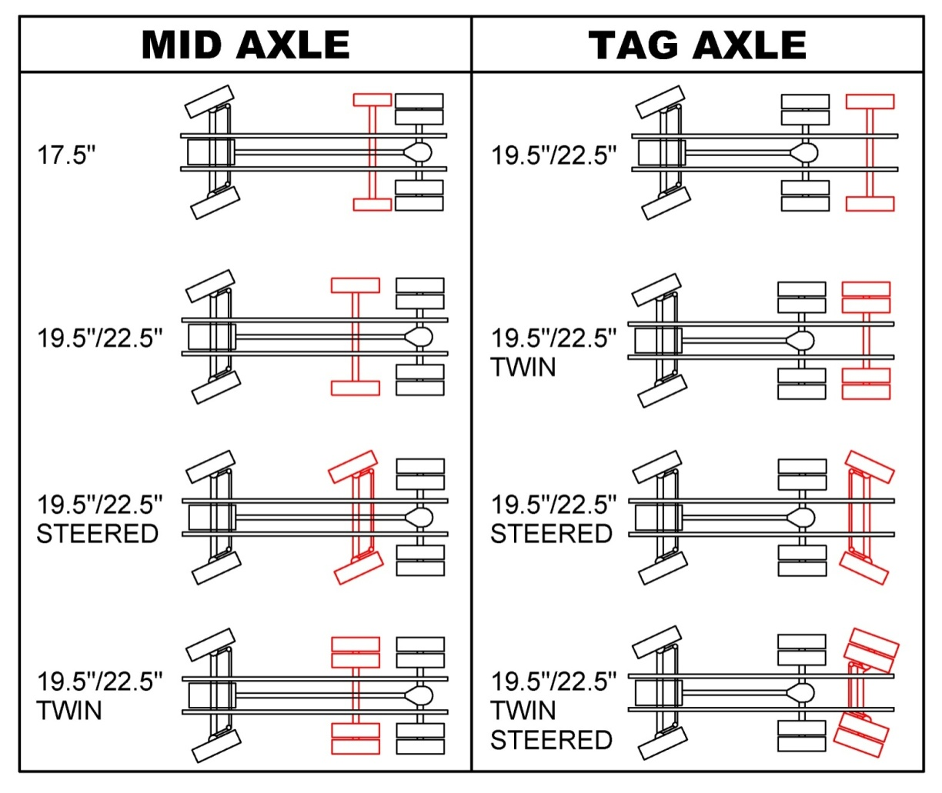

L R L R

Off Road Usage: Yes No
EBS/ ECAS/ ODR data Yes No
Failure codes Steering system Yes No

* NOTE: EBS / ODR data, failure codes and written proof of service history needs to be made available upon request by VDL.

Pictures of applicable item(s)

Position | Picture
Top
Bottom
Left Side
Right Side
Back side
Front Side
Detailed Picture(s) of Damage
Additional

Type of truck
Configuration
Axle load, trailing arm width, etc.
Phone, Email, etc.

